Homework II- Thermistors

Jamie Gashler- JAVA programming

* The JavaDoc is important because it allows you to import data and documentation from Java source files. It is important to learn to navigate and read the JavaDoc because it stores information on the relevant and specific APIs that are useful for understanding the class structure and code available in Java.
* When I looked in the JavaDoc for the Math Class, the method I used to calculate the logarithm was **log**(double a) because this method, in java.lang.Math, returns the natural logarithm (base e) of a double value. I used it because the .lang package was already imported into the java compiler, and this method accomplished what was needed to complete the equation.
* If something in the JavaDoc is listed as deprecated, then it has been marked as obsolete and outdated. It is strongly suggested to avoid using deprecated members because there are often better alternatives, and certain deprecated members might not even remain supported on java platforms.

Resistance of **5000**

**Result:**

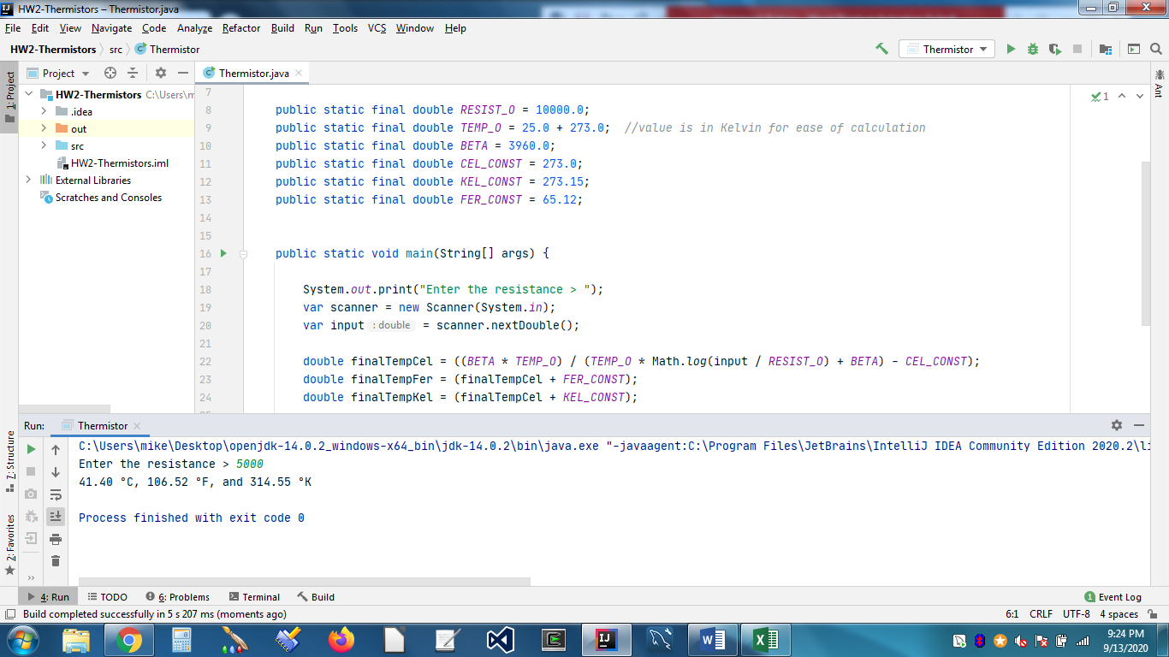

Resistance of **450**

**Result:**

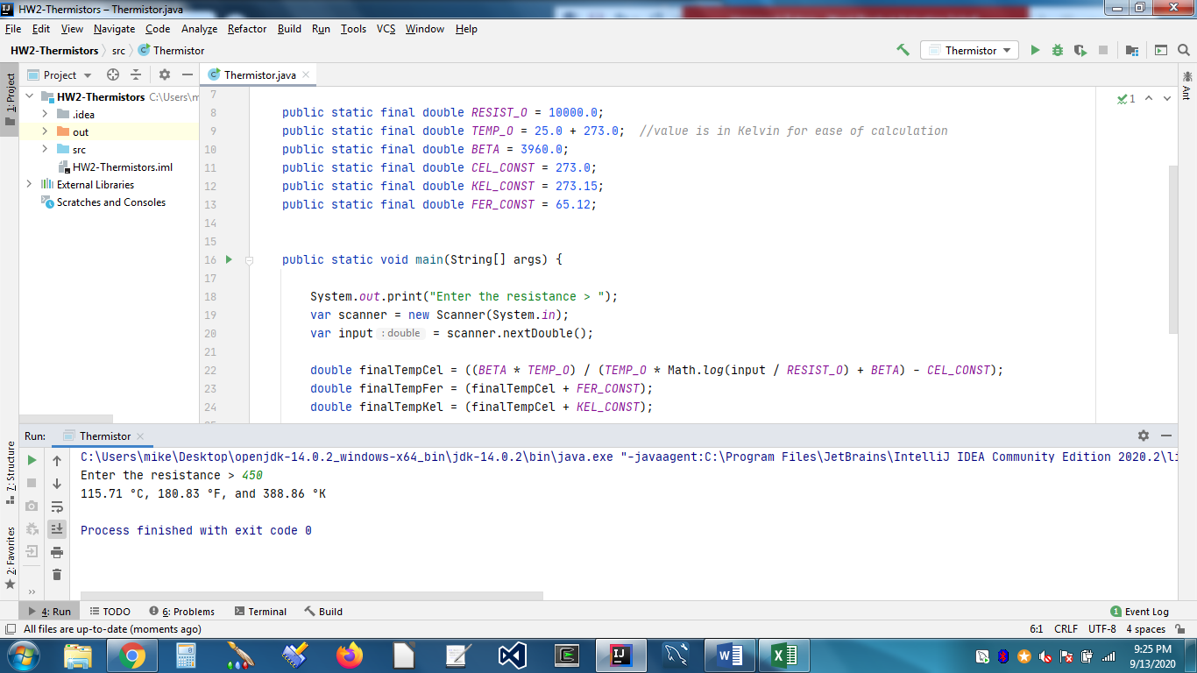

Resistance of **2579**

**Result:**

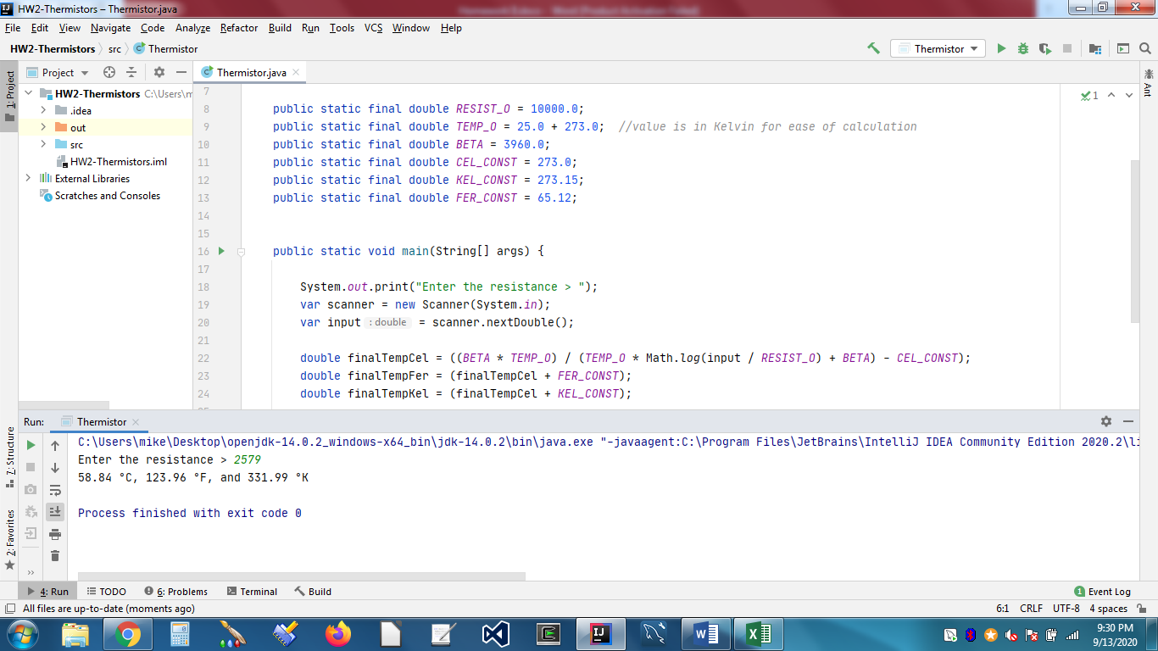

Resistance of **8059**

**Result:**

